Required Practical 8: Investigation into the effect of a named factor on the rate of dehydrogenase activity in extracts of chloroplasts:

The effect of ammonium hydroxide on the time taken for chloroplasts to decolourise DCPIP

The named factor is ammonium hydroxide that affect the light dependent reaction in a similar way to weed killer.

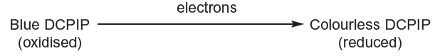

Method:
- Spinach leaves without the midrib (no chloroplasts present in midrib) are blended in a cold (stops enzyme activity/damage to hloroplast), isotonic (prevents shrinking/bursting of chloroplast due to osmosis) isolation medium using blender, which break open cells releasing chloroplasts. The blended mixture is filtered, the filtrate is the chloroplast suspension.
- Set up 5 tubes and illuminate using lamp:
- A: 5 cm3 DCPIP + water + chloroplast suspension, wrap in aluminium foil
- B: 5 cm3 DCPIP + water + isolation medium
- A and B are controls
- C: water + chloroplast suspension used as standard to determine colour change
- X: 5 cm3 DCPIP + water, Add chloroplast suspension and start timer, record number of seconds taken to change colour from blue-green to green. Use C to determine when colour change is complete. Repeat four more times to get sufficient data for statistical test
- Tube Y: B: 5 cm3 DCPIP + ammonium hydroxide. Add chloroplast suspension and start timer, record number of seconds taken to change colour from blue-green to green. Use C to determine when colour change is complete. If no colour change record colour after 300 seconds and use data table provided for statistical test

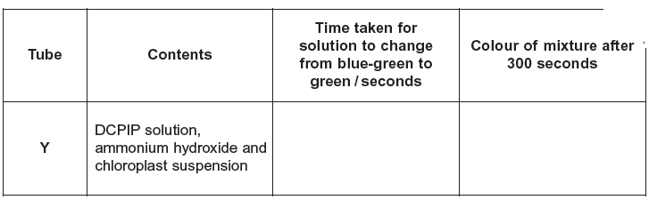
green

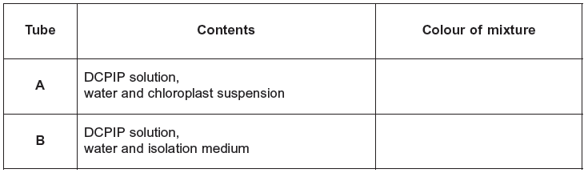
blue-green
blue-green

- Aluminium foil in tube A prevents entry of light, so slows the release of electrons from chlorophyll because release of electrons only occurs in the light.
- Colour does not change in B, showing that colour change in tube X is due to chloroplasts, not due to isolation medium
- DCPIP is decolourised more slowly when ammonium hydroxide is added because ammonium hydroxide has stopped transfer of electrons along electron transport chain to DCPIP
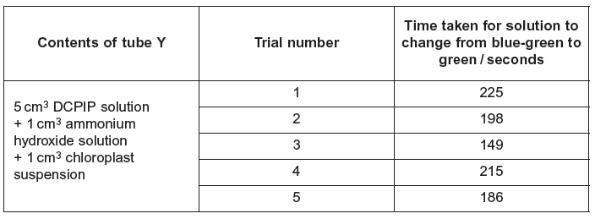

Use the data provided for tube Y and your own data in tube X for statistical test.

Null Hypothesis: ammonium hydroxide has no effect on the time taken for colour change
Statistical Test: Standard error (and 95% confidence limits) because Comparing two means

Accept/reject null hypothesis using test statistic result

Exam Question Practice:

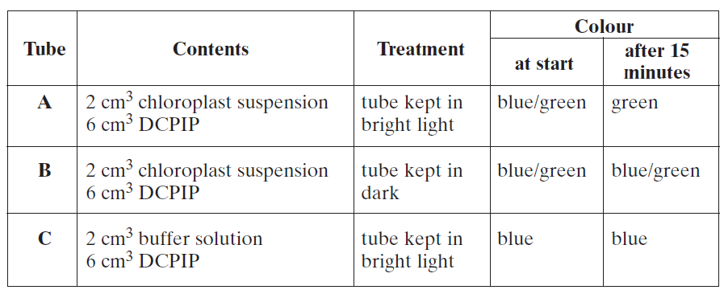

Explain colour change in tubes A, B and C:

- In tube A excitation of chlorophyll by light releases electrons, which reduce DCPIP, blue DCPIP becomes colourless, so only see green colour of the chlorophyll.
- Tube B shows light is necessary for the release of electrons and the colour change / Tube B would also become green if mitochondria supplied electrons
- Tube C shows that chloroplast / chlorophyll is necessary for colour change

