Photosynthesis

Overview and Pigments
Photosynthesis involves the absorption of light, where the wavelengths used in light absorption are those utilized for the photosynthetic process. Chlorophyll a is the primary pigment, most effectively absorbing blue light at 440 nm. The relationship between the absorption and action spectra shows that wavelengths used in light absorption are then used in photosynthesis. Accessory pigments, including chlorophyll b, chlorophyll c, carotene, and xanthophyll, broaden the range of light absorbed and pass energy to the reaction centres. In deep-water environments, red seaweeds use a pigment called phycoerythrin to absorb green and yellow light (500-600 nm), which penetrates deeper than the red and blue wavelengths used by green algae in surface waters.

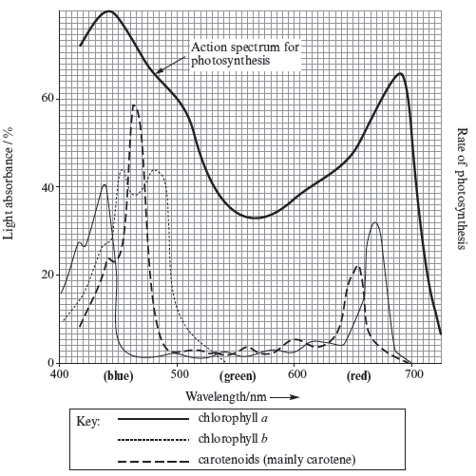

Chloroplast Structure and Function
The structure of the chloroplast is specifically adapted to facilitate both stages of photosynthesis:
- Thylakoid Membrane: Protons (H+) are pumped across this membrane by proton pumps using energy derived from electron flow.
- Thylakoid Space: This region allows for the buildup of a high concentration of H+ ions, resulting in a low pH.
- ATP Synthase: Protons flow down their concentration gradient through this protein, providing the energy required for ATP synthesis.
- Stroma: This is the site where free electrons are taken up by the final electron acceptor, NADP, and where the Calvin cycle (light-independent reaction) occurs.

ATP Synthase: Protons /hydrogen ions (H⁺) flow down a concentration gradient and provide the energy for ATP synthesis

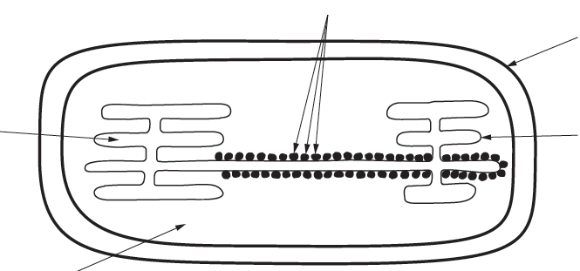
Thylakoid space: A high concentration of proton/ hydrogen ions (H⁺) builds up, pH low

Thylakoid membrane: Protons/ hydrogen ions (H⁺) are pumped across the thylakoid membrane by proton pumps using the energy from electrons flow

Stroma: Free electrons are taken up by a final electron acceptor (NADP)

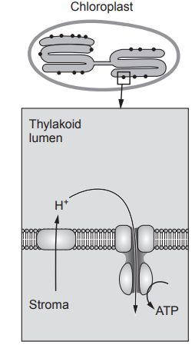

The Light-Dependent Reaction (LDR)
The LDR begins when pigments absorb photons, which excites electrons in chlorophyll to a higher energy level. This excitation triggers photolysis, the splitting of water into electrons, protons, and oxygen (). These electrons are passed along an electron transport chain (ETC) to produce ATP and reduced NADP (NADPH), both of which are required for the light-independent stage.
H₂O 2H+ 2e⁻ + ½ O₂

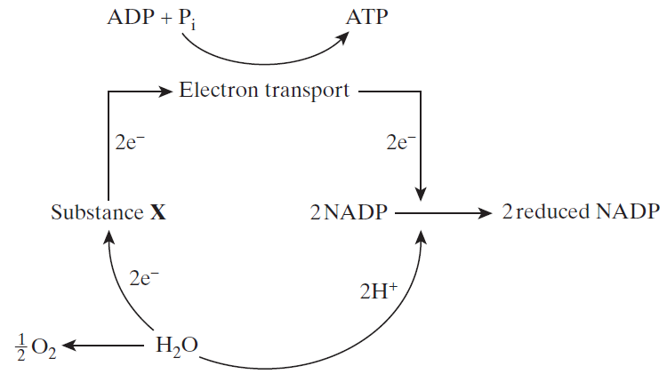
(2NADPH)
Chlorophyll

The Light-Independent Reaction (Calvin Cycle)
The Calvin cycle takes place independently of light but is highly sensitive to temperature because it is controlled by enzymes. The enzyme RuBisCO is responsible for fixing carbon dioxide. The cycle involves the conversion of RuBP to GP and then to TP (Triose Phosphate). TP serves as a precursor for various organic molecules, including amino acids and fatty acids.

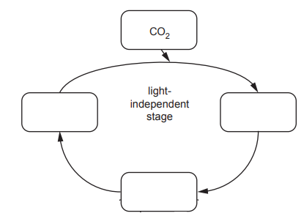
RuBP
TP
GP

Factors Affecting Photosynthesis
The rate of photosynthesis is influenced by several environmental limiting factors:
- Light Intensity: Low intensity results in fewer excited electrons, less photolysis, and a reduced yield of ATP and NADPH.
- Temperature: High temperatures can deactivate RuBisCO, damage the thylakoid membrane, and cause stomata to close, which reduces the available for the Calvin cycle.
- Concentration: At the compensation point, the rate of photosynthesis exactly matches the rate of respiration, meaning there is no net uptake or release of .
- Soil pH: A low soil pH reduces the availability of essential ions, such as magnesium for chlorophyll synthesis and phosphates for ATP/NADP production.
Practical Investigations
- Chromatography: This process separates photosynthetic pigments based on their solubility in a solvent; the more soluble a pigment is, the further it moves, resulting in a higher Rf value.

A small drop of the chlorophyll extract was placed on the chromatography paper in a test-tube containing a different solvent (S2) and left for 10 minutes.

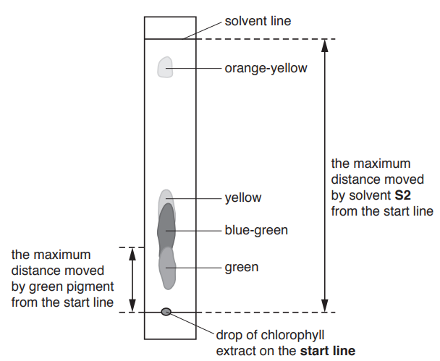

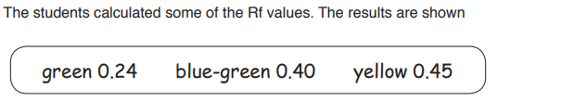
Green moves the least distance / smallest Rf value

- DCPIP: This dye is used to investigate dehydrogenase activity in the LDR. Blue DCPIP acts as an artificial electron acceptor and is reduced to a colourless state by electrons released during photolysis.
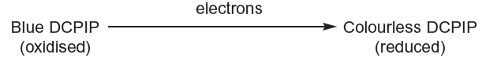

- In a chloroplast suspension, this causes a colour change from blue-green to green (the colour of the chlorophyll).
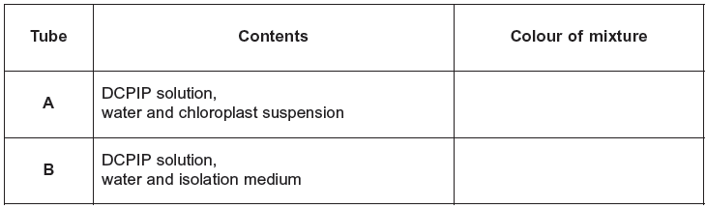
blue-green
blue-green

- Aluminium foil in tube A prevents entry of light, so slows the release of electrons from chlorophyll because release of electrons only occurs in the light.
- Colour does not change in B, showing that colour change in tube X is due to chloroplasts, not due to isolation medium
- Inhibitors like ammonium hydroxide can slow this process by stopping the transfer of electrons along the ETC.

How do environmental factors like CO2 affect photosynthesis rates?
Environmental factors like concentration significantly influence photosynthesis rates, as is a primary substrate for carbon fixation. The following details describe how levels and related environmental conditions affect this process:
Direct Impact on Photosynthesis Rate
- Rising levels: In general, if concentrations rise, the rate of photosynthesis will also rise, which can lead to greater plant productivity.
- Limiting Factors at Depth: In aquatic environments, levels (along with light and temperature) are reduced with increasing depth, which in turn reduces photosynthesis and glucose production.
- The Compensation Point: This is the specific light intensity at which the rate of photosynthesis exactly matches the rate of respiration. At this point, there is no net uptake or release of because the produced by respiration is entirely used by photosynthesis.

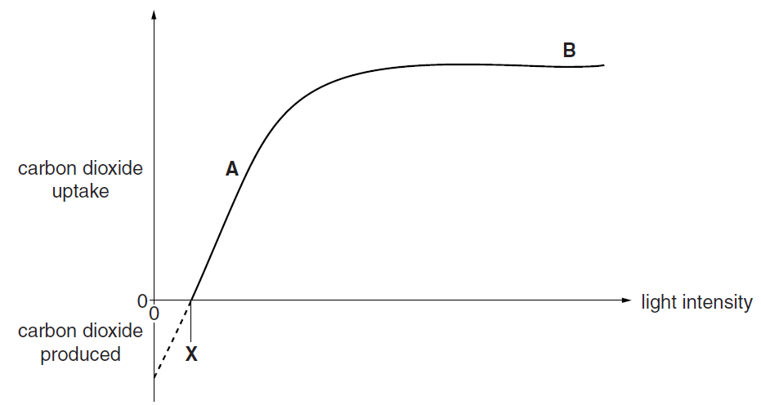

The Role of Stomata and Temperature
- Stomatal Closure: Environmental stressors like very high temperatures can cause stomata to close. This reduces the amount of available for fixation in the light-independent reaction (Calvin cycle), thereby decreasing the photosynthetic rate.
- Enzyme Activity: The enzyme RuBisCO is responsible for fixing during the Calvin cycle. However, under certain conditions, RuBisCO can also fix oxygen instead of (a process called photorespiration), which reduces efficiency.
Environmental Variations
- Soil Level vs. Canopy: In a forest, levels at soil level are often higher because there are fewer leaves to remove it and high levels of are produced by decomposition and respiration from soil organisms.
- Forests as Sinks: Trees in ecosystems like deciduous forests act as carbon sinks, removing more through photosynthesis than they return via respiration.

