Worksheet Amount of substance – MOLE

Calculating Maximum Mass:
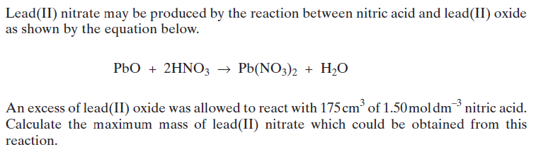

Calculating Moles Using Balanced Equation:

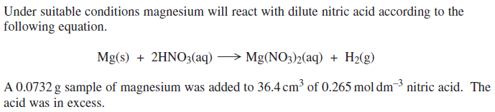

Moles at the start
Moles reacted

Moles unreacted remaining

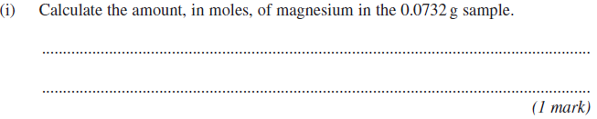
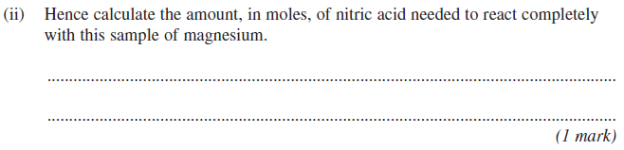
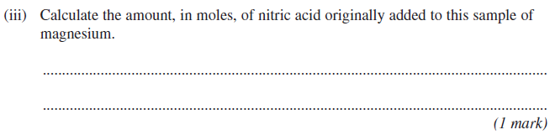

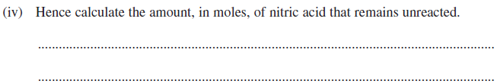

Titration:

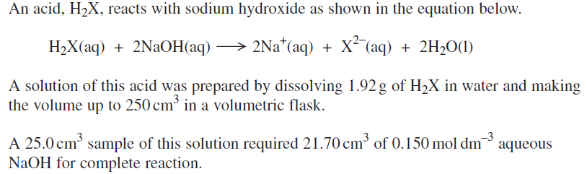

Calculate the amount in moles of the acid that has reacted with sodium hydroxide.

Moles at the start
Moles reacted

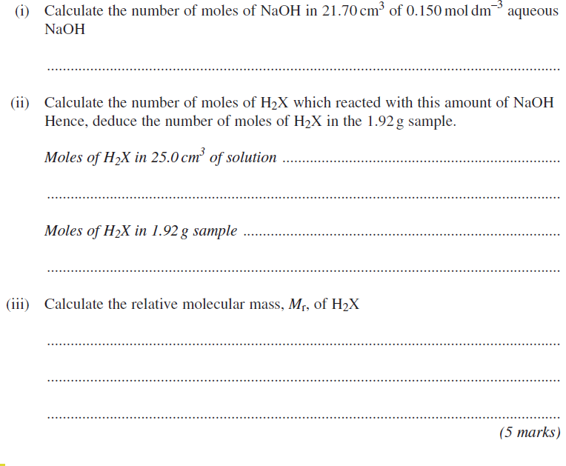

Back Titration:
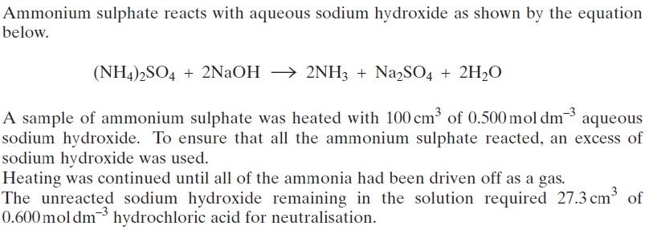
Calculate the number of moles and the mass of ammonium sulphate in the sample.
Moles at the start

Moles reacted

Moles NaOH unreacted remaining = (from back titration)

Moles (NaOH) reacted =

Mass ammonium sulphate =
Moles (NH₄)₂SO₄ reacted =

Mass ammonium sulphate = moles x Mr

Back titration:
Moles HCl
Moles NaOH

NaOH + HCl H₂O + NaCl

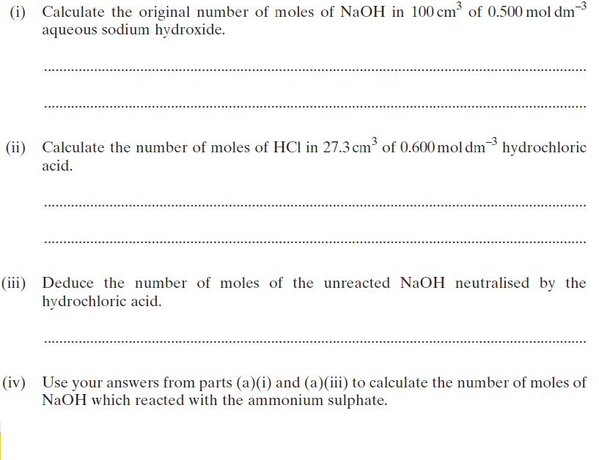
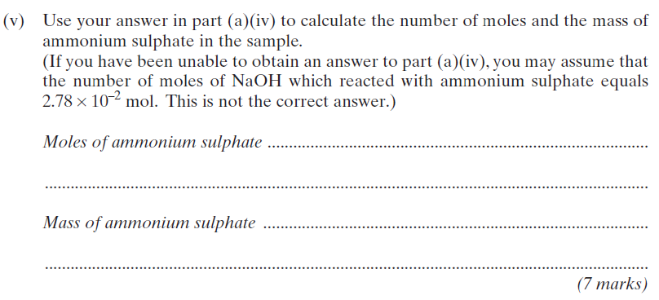

Water of crystallisation:
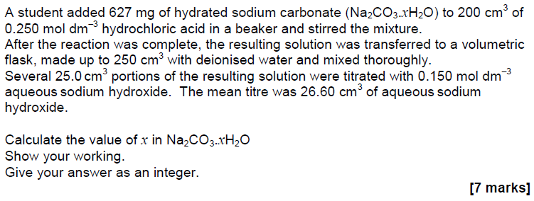
Moles at start
Moles reacted

Na₂ CO₃ x H₂O + 2HCl H₂O + CO₂ + 2NaCl

Moles HCl in in 250 cm³

Need to work out moles of Na₂CO₃ x H₂O in the above equation and then use it with the mass given to find M_{r} of Na₂ CO₃ x H₂O. Finally work out the mass of water in Na₂ CO₃ x H₂O and the moles of water.

Back titration:
In this reaction the HCl is used in excess. Back titration with NaOH allows you to work out the moles of excess HCl after the reaction has completed and then using this value work backward to calculate the moles of HCl that has reacted. Then deduce the moles of Na₂ CO₃ x H₂O
Moles HCl
Moles NaOH

Na OH + HCl H₂O + NaCl

Moles NaOH used to neutralise excess HCl =
Therefore, mole HCl in excess = (in 25 cm³) = (in 250 cm³)
Now calculate moles of HCL that have reacted
Moles HCl reacted =
Therefore, moles of Na₂CO₃ x H₂O =
Now using the moles and mass of Na₂CO₃ x H₂O, work out M_{r} of Na₂CO₃ x H₂O.
M_{r} of hydrated salt (Na₂CO₃ x H₂O) =
M_{r} of anhydrous salt (Na₂CO₃) =
Therefore, mass of water in Na₂CO₃ x H₂O =
Mole of water =
X=

Calculations using Avogadro’s constant
Number of atoms/molecules/particles in a substance = number of moles x 6.022 x 10²³

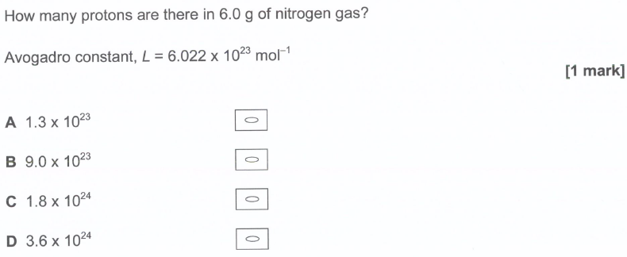

Moles and Balanced Equations

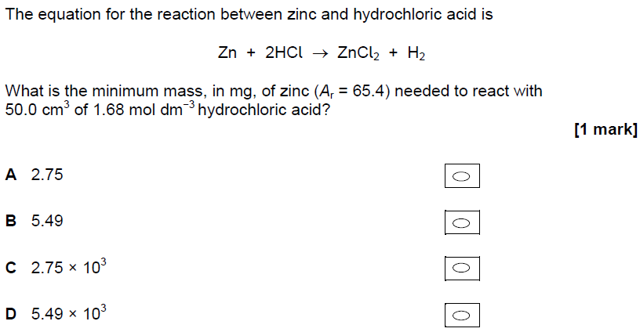

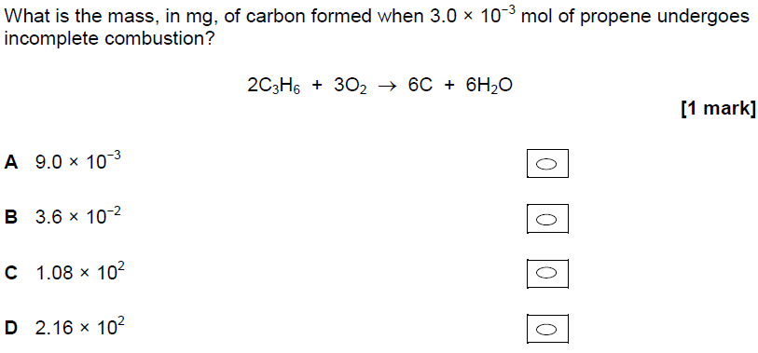

Reacting Volume of Gasses

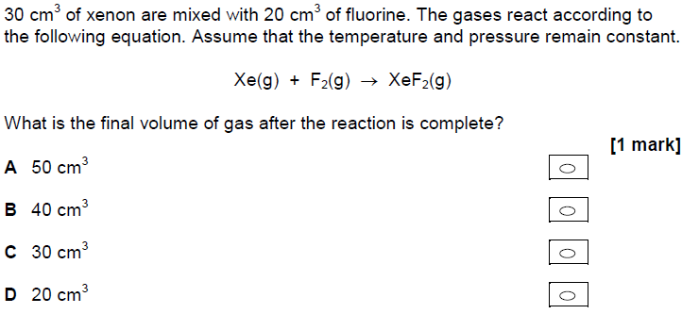

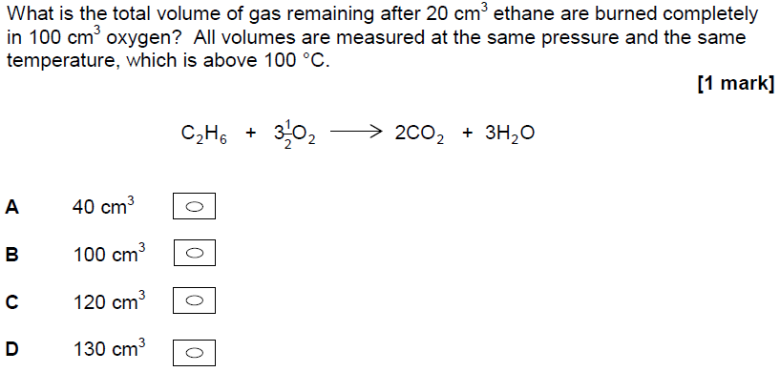
Reacting volume
Initial volume
Volume remaining:
Answer:

Percentage Yield:

