Calculating the number of molecules of water of crystallisation in hydrated salts

Magnesium sulfate is a hydrated salt as it contains water molecules

Find out the formulae of the hydrated magnesium sulphate by calculating the numbers of water molecules (value of x).

Use the following experimental data:

Mass of the hydrated salt, MgSO₄ .x H₂O = 4.321g
Mass of the anhydrous salt, MgSO₄ = 2.107g

Mass of water = 4.321-2.107 = 2.214

Moles of water = 2.214 ÷ 18 = 0.123

Moles anhydrous MgSO₄ = 2.107 ÷ 121.4 = 0.0175

Mole Ratio:
MgSO₄ : H₂O
0.0175 : 0.123
1 : 7
X = 7
MgSO4.7H2O

In an experiment, the Mr of a hydrated sodium carbonate was found to be 250.
Use this value to calculate the number of molecules of water of crystallisation, x, in this
hydrated sodium carbonate, Na2CO3.xH2O

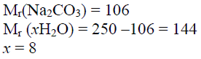

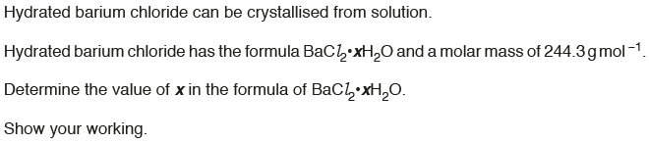

Molar mass anhydrous BaCl₂ = 208.3

Molar mass H₂O in BaCl₂.xH₂O = 244.3 – 208.3 = 36

X = 36 / 18
X = 2

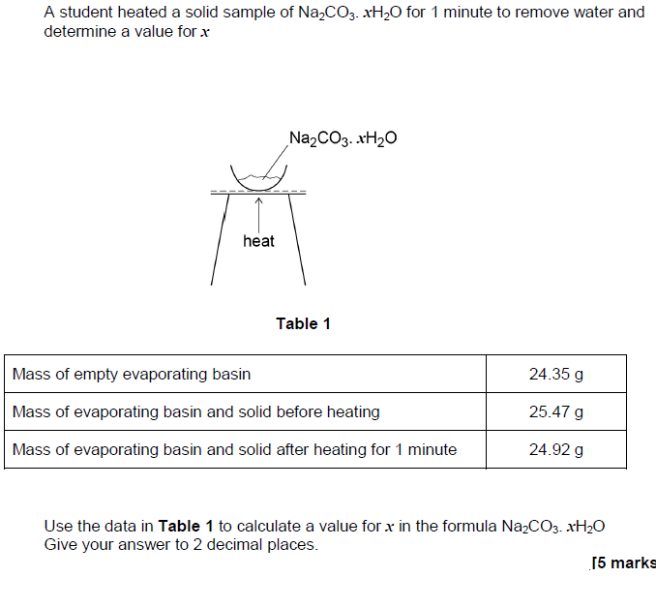

Mass Na2CO3. xH2O = 25.47 – 24.35 = 1.12 g
Mass Na2CO3. = 24.92 – 24.35 = 0.57 g
Mass of water lost during heating = 1.12- 0.57 = 0.55 g
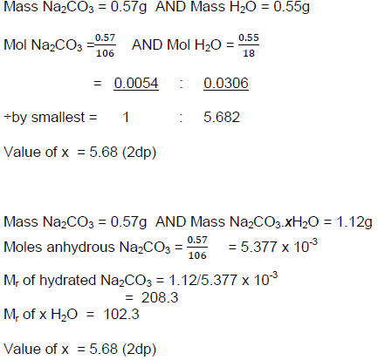

5Fe²⁺ + 8H⁺ + MnO⁴⁻ 5Fe³⁺ + Mn²⁺ + 4H₂O

Mol MnO⁴ = 4.385 x 10⁻⁴

Mol Fe²⁺ (From the balanced equation) = 4.385 x 10⁻⁴ x 5 = 2.193 x 10⁻³

Mol Fe²⁺ in 500 cm³ = 20 x 2.193 x 10⁻³ = 0.04385

Mr FeSO₄.xH₂O = mass ÷ mole = 12.18 ÷ 0.04385 = 278 g

Mr FeSO₄ = 152 g

Mass of water = 278-152 = 126 g

Mole water = 126 ÷ 18 = 7

X = 7

Specification: Determine the number of moles of water of crystallisation in a hydrated salt by titration
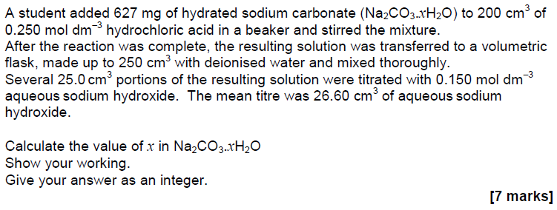

Mass/Mole added 0.627g 0.050
Na₂ CO₃ x H₂O + 2HCl H₂O + CO₂ + 2NaCl

Need to work out moles of Na₂CO₃ x H₂O in the above equation and then use it with the mass given to find M_{r} of Na₂ CO₃ x H₂O. Finally work out the mass of water in Na₂ CO₃ x H₂O and the moles of water.

Back titration:
In this reaction the HCl is used in excess. Back titration with NaOH allows you to work out the moles of excess HCl after the reaction has completed and then using this value work backward to calculate the moles of HCl that has reacted. Then deduce the moles of
Na₂ CO₃ x H₂O

Na OH + HCl H₂O + NaCl

Moles NaOH used to neutralise excess HCl = 3.99 x 10⁻³
Therefore, mole HCl in excess = 3.99 x 10⁻³ (in 25 cm³) = 3.99 x 10⁻² (in 250 cm³)
Now calculate moles of HCL that have reacted
Moles HCl reacted = 0.05 - 3.99 x 10⁻² = 0.0101
Therefore, moles of Na₂CO₃ x H₂O = 0.0101÷2 = 5.05 x 10⁻³
Now using the moles and mass of Na₂CO₃ x H₂O, work out M_{r} of Na₂CO₃ x H₂O.
M_{r} of hydrated salt (Na₂CO₃ x H₂O) = 0.627÷ 5.05 x 10⁻³ = 124
M_{r} of anhydrous salt (Na₂CO₃) = 106
Therefore, mass of water in Na₂CO₃ x H₂O = 124-106 = 18
Mole of water = 18÷18=1
X=1

Summary:
Amount of HCl remaining after the reaction is complete (excess HCl) is used to neutralise NaOH
Mole NaOH used in back titration to neutralise excess HCl in 25 cm⁻³ = 3.99 x 10⁻³ mol
Mole NaOH used in the titration to neutralise excess HCl in 250 cm⁻³ = 3.99 x 10⁻² mol
Moles of HCl that reacted with the Na2CO3.xH2O = 0.050 - 3.99 x 10⁻² = 0.0101 mol
Moles of Na2CO3.xH2O reacted with the HCl = 0.0101÷2 = 5.05 x 10⁻³ mol
M_{r} Na₂CO₃ xH₂O = mass / mole = 0.627 / 5.05 x 10⁻³ = 124
M_{r} Na₂CO₃ = 106
Mass of H₂O in Na₂ CO₃ xH₂O = 124 – 106 = 18
Mole of water = 18÷18 =1
X = 1

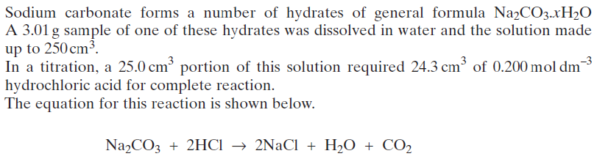

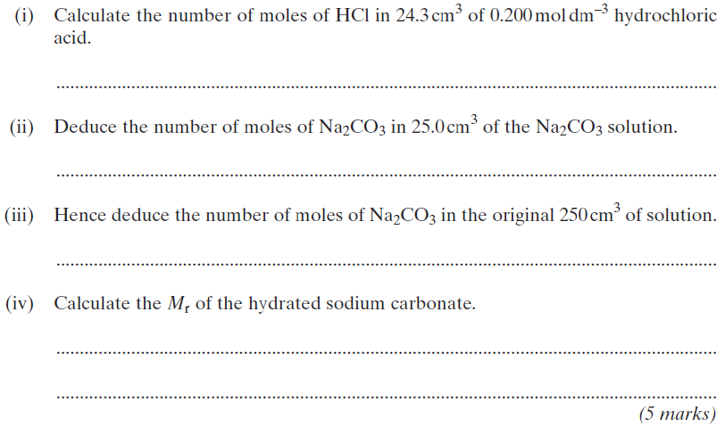

Calculate the number of molecules of water of crystallisation, x, in this
hydrated sodium carbonate, Na2CO3.xH2O

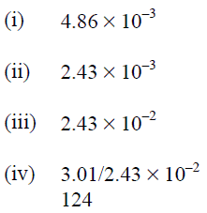

Mr(Na2CO3) = 106
Mr (xH2O) = 124 - 106 = 18
x = 1

OCR:
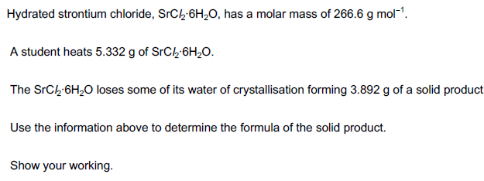
Need to work out how many water molecules are lost from SrCl₂.6H₂O

Mass of hydrated salt = 5.332 g
Mass of anhydrous salt = 3.892
Mass of water lost = 1.44 g
Mole water lost = 1.44/18 = 0.08
Mole of hydrated salt heated = 5.332/266.6 = 0.02
Mole Ratio of water lost to hydrated salt = 0.08: 0.02
Whole number ratio = 4:1
4 moles of water are lost and 2 remaining, therefore, formula of solid product = SrCl₂.2H₂O

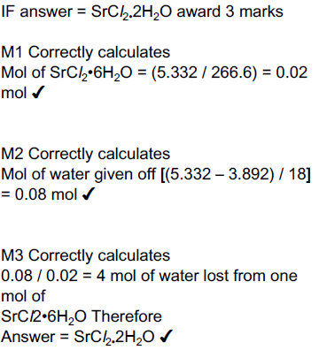

Edexcel:

A student made crystals of a metal chloride, JCl2.6H2O, by reacting the
metal carbonate, JCO3 , with hydrochloric acid, HCl (aq). 150 cm3 of hydrochloric acid, concentration 0.80 mol dm−3, was transferred to a 400 cm3 conical flask.

The equation for the reaction between the metal carbonate and hydrochloric acid is
JCO3(s) + 2HCl(aq) → JCl2(aq) + H2O(l) + CO2(g)

The student obtained a mass of 14.26 g of hydrated crystals.
Assuming that the percentage yield is 100%, use the information in the procedure
to give a possible identity of J. (5)

Mole HC added = 150/1000 x 0.800 = 0.12(0) (mol)
Mole JCl2 = 0.12 / 2 = 0.06(00) (mol)
Mr JCl2 = 14.26 / 0.0600 = 237.7 (g mol-1)
Mr 6H2O = 108
Mr JCl2.6H2O = 237.7 + 108
Mr Cl2= 71
Ar J = 237.7 - (71 + 108) = 58.7 (g mol⁻¹)
J is Ni

